**Project Development Phase Delivery of Sprint-1**

|  |  |
| --- | --- |
| **Team Id** | PNT2022TMID14106 |
| **Project Name** | **Visualizing and Predicting Heart Disease with an Interactive Dashboard** |

**Project Development Phase:**

**Sprint-3:**

**Bp by age coloured by sex:**

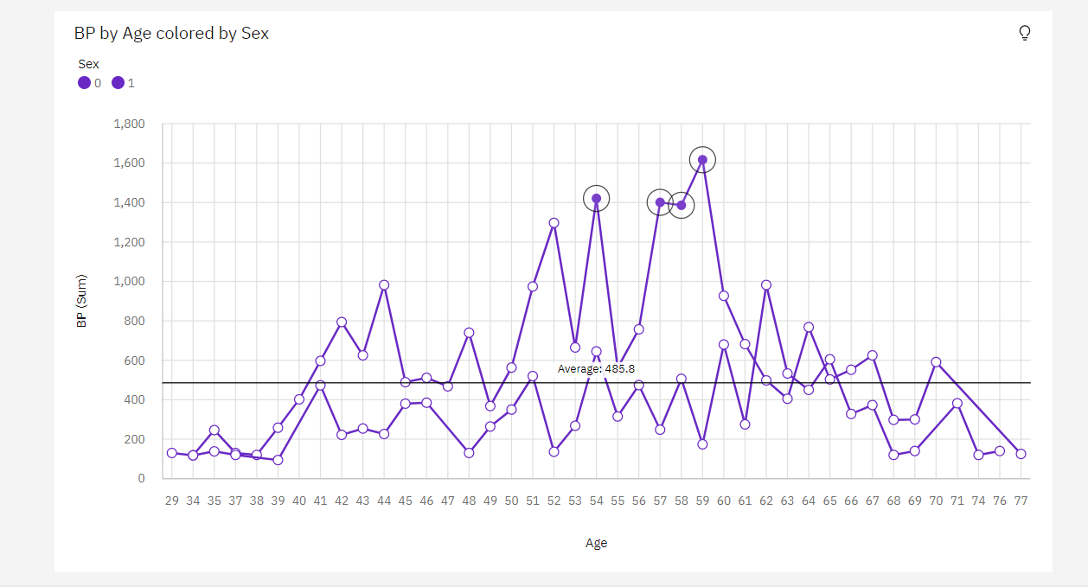

**Max HR and Exercise angina by Heart Disease:**

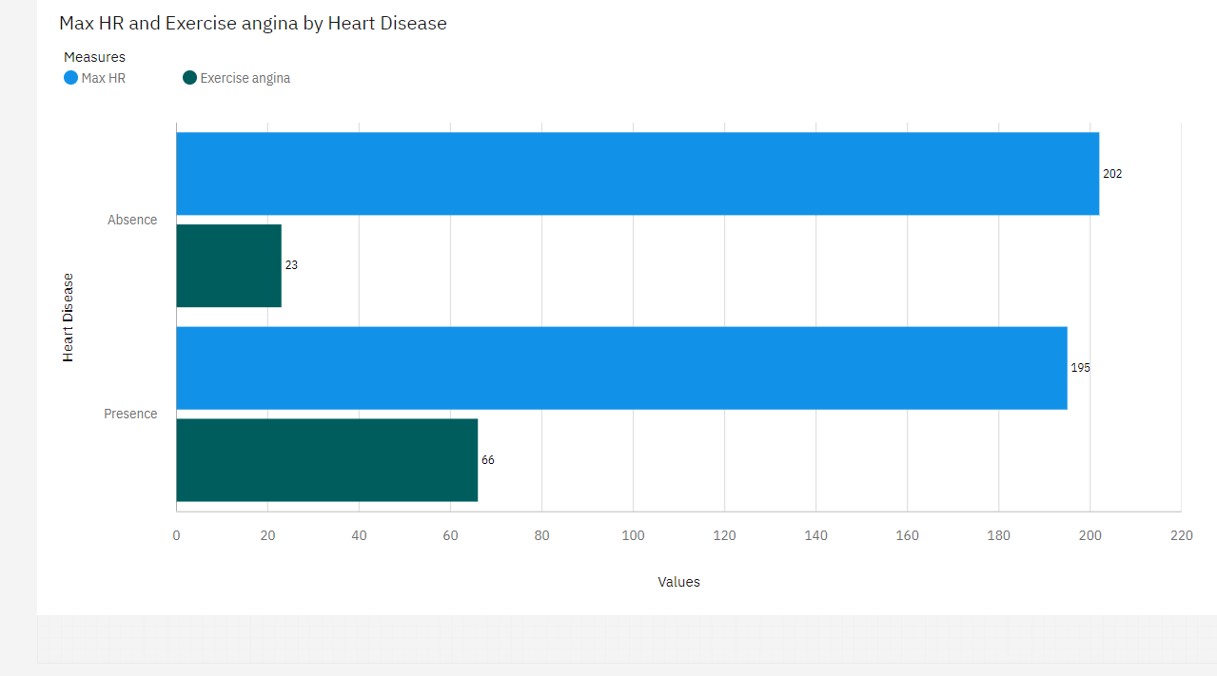

**Average Exercise Angina During Chest Pain:**

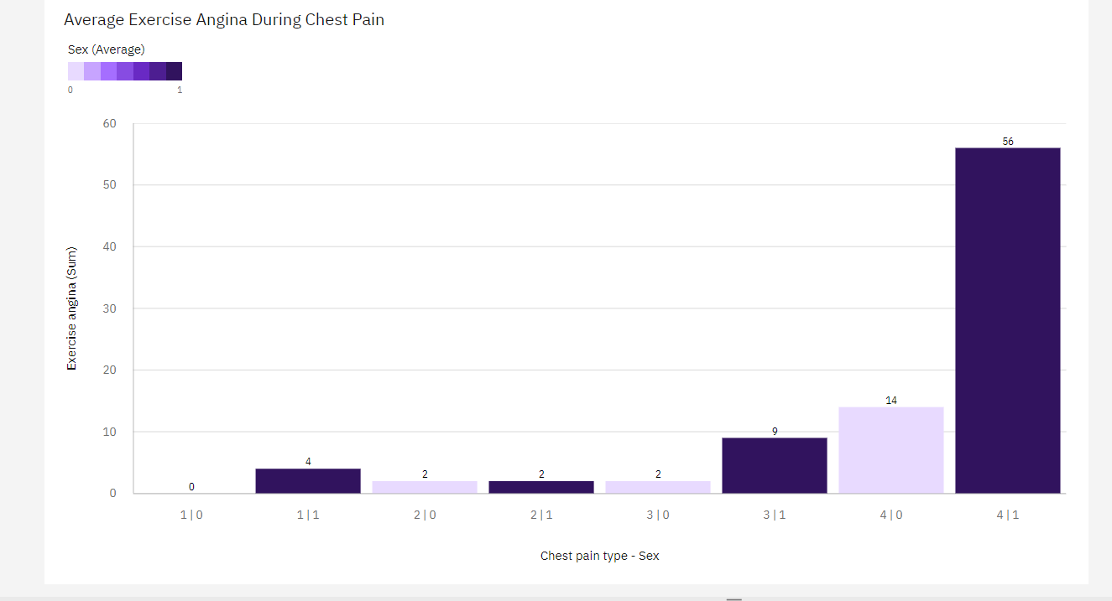

**Average Age For Different Chest Pain Types:**

